**HO CHI MINH CITY UNIVERSITY TECHNOLOGY AND EDUCATION**

🞠◊🞠◊🞠



**LECTURER**

**LE VINH THINH**

**Final Project**

**E-Commerce Website Using MERN Stack**

**New technologies in software engineering**

**GROUP MEMBERS:**

**Ho Vu Minh Duc - 17110022**

**Nguyen Quang Minh - 17110051**

**SEMESTER: 1 – YEAR: 2020-2021**

**HO CHI MINH CITY**

# EVALUATION AND SCORE

## **EVALUATION:**

## 

## 

## 

## 

## 

## 

## 

## **SCORE:**

|  |  |
| --- | --- |
| **WORD** | **NUMBER** |
|  |  |

# PREFACE

New Technologies in Software Engineering (NTISF) is a quite interesting and difficult object but it also helps us know more about the technologies we use in daily application. Our project is to develop an E-Commerce Website using MERN Stack. It is pretty difficult for us but thank to our lecture we can complete it. We are grateful to him.

Thank you,

Mr.Thinh

Le Vinh Thinh

Contents

EVALUATION AND SCORE 2

EVALUATION: 2

SCORE: 2

PREFACE 2

I. Project Overview 4

A. Definition 4

B. System Configuration 4

II. Task Distribution 5

III. Project’s Detail 5

IV. References 9

V. Resource 11

# I. Project Overview

## **A. Definition**

Our project is to develop an E-Commerce Website using MERN Stack. We try our best to do our topic.

**MERN** stack is a web development framework. It consists of MongoDB, ExpressJS, ReactJS, and NodeJS as its working components. Here are the details of what each of these components is used for in developing a web application when using MERN stack:

* **MongoDB**: A document-oriented, No-SQL database used to store the application data.
* **NodeJS**: The JavaScript runtime environment. It is used to run JavaScript on a machine rather than in a browser.
* **ExpressJS**: A framework layered on top of NodeJS, used to build the backend of a site using NodeJS functions and structures. Since NodeJS was not developed to make websites but rather run JavaScript on a machine, ExpressJS was developed.
* **ReactJS**: A library created by Facebook. It is used to build UI components that create the user interface of the single page web application.

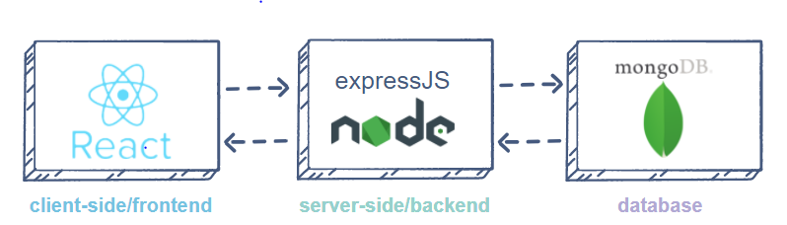

## **B. System Configuration**

We write the website by using MERN Stack in Visual Studio Code. The source code can run on every common OS such as Windows, macOS,…

Note: NodeJS >= 10.15.3 is recommended to run the code successfully, older version might not work

# II. Task Distribution

|  |  |
| --- | --- |
| **Members:** | **Task:** |
| Nguyen Quang Minh | Front-End |
| Ho Vu Minh Duc | Back-End |

# III. Project’s Detail

Our project is an electronic store which user can purchase and check order details. Screenshots below describe mostly our project’s details.

**Home Page**

**Sign In Page**

**Sign Up Page**

In sign in page, we can go to sign up page to make new account or login by Google, Facebook,…

**Profile Page**

We can go to profile page to check out purchased orders

**Homepage**

The homepage will be showed whenever we have an account or not, or logged in by user account or admin account.

The Homepage has the Cart button, Sign in button, Add to cart button, Search button,…

**Search page**

In this search page, we can search the name of the product we want.

**

In user management, admin can edit info and grant admin access to any user

**Product management page**

In product management page, admin can create/edit/delete product

**Order management page**

# In order management page, admin can check detail of orders and toggle delivered status to them

**Payment page**

We used Paypal (sandbox) payment system because it is convenient, users can make secure payment from anywhere, any time without restrictions

# IV. References

Our lecturer’s materials on FHQ and video on Youtube.

# V. Resource